Charlie Baker

Garima Dubey

Clarke Eastman-Pinto

**Priming Effects and Word Usage**

Recent prior research regarding priming, or the act of consciously or subconsciously introducing information to the participant before a task, points to a potentially more significant effect than one would expect on task performance. The purpose of the study is to address the question “Is cognitive priming reflected in the usage of language?” We hypothesize that participants primed with the presentation of certain chargedwords would impart some effect on the tone of free-written prose that followed. The state of the art regarding priming is a plethora of specific cases yielding conflicting results. Different studies have explored the myriad possible effects of priming on our thoughts and our behavior, such as helping us to process information (Henson, 2003), increasing more innate feelings such as thirst (Strahan, 2002), and persuading us to buy certain products (Elgendi et al, 2018). However, little research has explored how priming may affect creative production rather than processing, which is our aim with supraliminal messaging in advance of prompts.

**Methodology**

To test our hypothesis, we created a slideshow of 5 slides containing neutral story prompts. Experiment subjects were asked to produce a story around each one of the neutral prompts. A positive, negative or neutral word/symbol was flashed in the form of subliminal messaging before every prompt. The flashing time of subliminal words was 0.1 second before every prompt. This time is beyond the usual limit for subliminal processing, and instead should be considered supraliminal and thought of as being consciously perceived to some degree by the participants. We formulated the experiment in the form of a google form, where test subjects saw the recorded slideshow and answered the prompts on the google forms.

After collecting all the responses, we formatted them into txt files so we were able to parse through them. Using a jupyter notebook python file we loaded up the txt files and isolated them by subliminal messaging. Slides 2 and 5, which displayed the words happiness and inspiration as subliminal messages, were categorized as positive, while slides 1 and 3, which displayed the words shame and hatred as subliminal messages, were categorized as negative. Our control was slide 4.

Using the commonly used [nrc emotion lexicon](https://saifmohammad.com/WebPages/NRC-Emotion-Lexicon.htm) we parsed through the txt files and associated the words with emotions/sentiments. We then processed these as counts per positive or negative subliminal message and normalized them in relation to how many words were in the response documents. In the graph below one can see the comparison of the normalized counts across the three test groups.

**Exhibits**

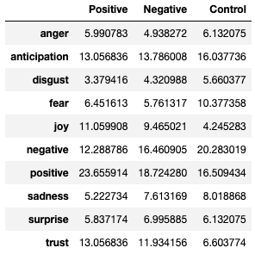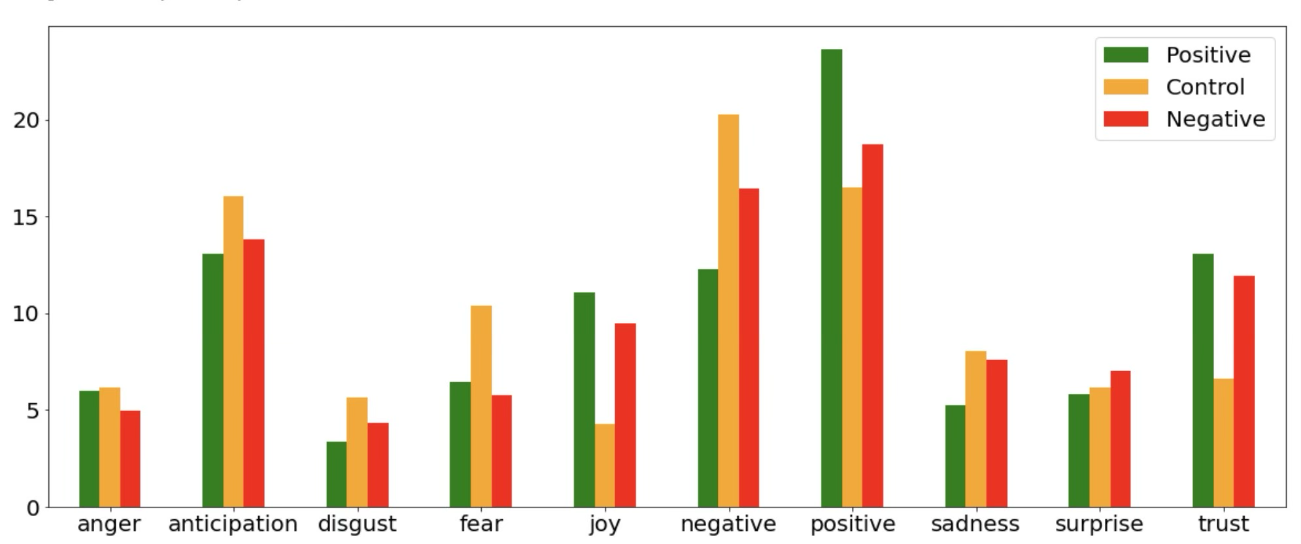

**Discussion**

We found that there are statistically significant differences in the positive and negative occurrence of words when presented with the corresponding prompt. This is the finding most generally supporting our hypothesis. There are, however, other findings that complicate this. For example, the presence of positive words in the negative prompts are higher than the negative words in the negative prompts. This is unexpected as we see our hypothesis supported by the higher number of positive words in the positive prompts. Additionally, we find that the control prompts actually had the highest presence of negatively associated words.

In future studies we would aim to eliminate confounds by randomizing prompt order, increasing our n-values with number of participants and number of prompts. Additionally, our prompts were as neutral as possible, but each participant brings his or her experience into reading each one. This renders no prompts universally neutral and may sway our results. Our findings suggest that subliminal information in a prompt does have general effects, but may not be as simply correlated as one might think.

**References**

Elgendi, M., Kumar, P., Barbic, S., Howard, N., Abbott, D., & Cichocki, A. (2018). Subliminal priming—state of the art and future perspectives. Behavioral Sciences, 8(6), 54.

Strahan, E., Spencer, S., Zanna, M. Subliminal priming and persuasion: Striking while the iron is hot, Journal of Experimental Social Psychology, Volume 38, Issue 6, 2002, Pages 556-568, ISSN 0022-1031

Henson, R. N. (2003). Neuroimaging studies of priming. Progress in neurobiology, 70(1), 53-81.

Pratte, M. S., & Rouder, J. N. (2009). A task-difficulty artifact in subliminal priming. Attention, Perception, & Psychophysics, 71(6), 1276-1283.

**Statement of Contribution**

Garima: Methodology, Discussion

Clarke: Discussion, Introduction, References  
Charlie: Methodology, Analysis of Data, Algorithm Composition